When I Lift Up My Head
Bass Sectional Notes

M42, the word "all" the correct note is a Bb, many of us are singing, I think, the Eb, same as the previous note on the word "just". The Bb is the same note we sing on the next word "roll", just go there one word sooner!!. Easy fix! You should see that measure below...............

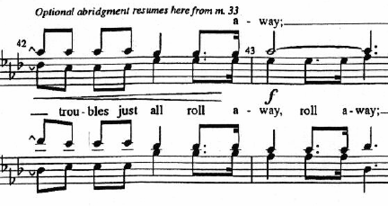

Also more than one of us missed the timing on the first "lift up my head, He lifts up my heart".

